FOR IMMEDIATE RELEASE
Tortuga AgTech wins Ag Robot of the Year 2024 award, Digital Workbench public favourite
8 February 2024 - Toulouse/Auzeville-Tolosane (France)
Tortuga AgTech's strawberry and table grape harvesting robot has emerged as the receiver of the Ag Robot of the Year 2024 award. Designed primarily for harvesting, this versatile robot also possesses the capability to collect data for forecasting, employ UV-C light for plant treatment, and perform trimming operations.
Geert Hekkert, editor in chief of Future Farming, and René Koerhuis, editor specialised in precision agriculture and robotics, announced the prestigious winner during the 8th edition of the World Forum for Agricultural Robotics (FIRA) in Toulouse/Auzeville-Tolosane, France, on Thursday, 8 February 2024. The Tortuga AgTech harvesting robot emerged victorious after a rigorous evaluation process that began with 12 initial candidates and culminated in five finalists. The expert jury, comprising Future Farming editors, a university researcher in robotics and precision agriculture, and farmers from across the globe, arrived at a unanimous decision, with the valuable addition of Anna Haldewang, founder and CEO of InsightTRAC, and winner of the Ag Robot of the Year award in 2023.
The other four finalists included the Andela Robot Weeder ARW-912, Digital Workbench Tipard 1800, Ekobot WEAI, and the Tensorfield Agriculture Jetty.
Each of the five finalists underwent a meticulous assessment by every jury member, individually measured against five key criteria:
- Originality/technical breakthrough.
- Feasibility/market readiness.
- Potential to impact farmers' lives.
- Ease of farmer adoption.
- Sustainability.

One of the compelling factors that led to Tortuga AgTech's selection as the winner is its pivotal role in addressing one of the most pressing challenges faced by the agricultural industry – the scarcity of affordable and skilled labour. The jury was also impressed by the robot's remarkable ability to harvest multiple types of fruits with a single robotic harvester, transforming what was once a vision into a practical reality. Notably, the Tortuga AgTech harvesting robot operates on a service contract basis, providing an economically viable alternative to labour shortages. Beyond harvesting and transportation, it offers a range of functionalities, including UV light treatment, runner trimming, and comprehensive data logging.
Future Farming and World FIRA jointly initiated the Ag Robot of the Year award to recognise field and harvest robots that meet the criteria of being practical, farmer-friendly, profitable, and scalable. Such robots can automate one or more operations in outdoor crop cultivation.
As part of the award, the Tortuga AgTech harvesting robot will be prominently featured in the promotion of the World FIRA event in 2025. Future Farming will also provide a canvas displaying the robot with the Ag Robot of the Year award logo. Additionally, JoJo's Vineyard, owned by jury member Ian Beecher-Jones from the UK, will offer a bottle of their finest wine to the winners.
In parallel with the expert jury's selection, the public was invited to choose their personal favourite among the finalists between 23 January and 4 February. The public favourite, announced alongside the expert jury's choice, was the Digital Workbench Tipard 1800, marking it as the 2024 favourite robot among readers.
{ Hii Gwendoline,
Here's the press release for the Ag Robot of the Year 2023 Award, as discussed earlier. We kindly request you to distribute this press release to the media contacts you work with or have at your disposal. Feel free to extract specific portions from the press release for other communications.
We'd like to emphasize that this press release should remain confidential until Thursday at 1:00 PM, as previously agreed.

Thank you in advance for your cooperation and see you tomorrow!

Best regards,
Geert }

FOR IMMEDIATE RELEASE
Tortuga AgTech wins Ag Robot of the Year 2024 award, Digital Workbench public favourite
8 February 2024 - Toulouse/Auzeville-Tolosane (France)
Tortuga AgTech's strawberry and table grape harvesting robot has emerged as the receiver of the Ag Robot of the Year 2024 award. Designed primarily for harvesting, this versatile robot also possesses the capability to collect data for forecasting, employ UV-C light for plant treatment, and perform trimming operations.
Geert Hekkert, editor in chief of Future Farming, and René Koerhuis, editor specialised in precision agriculture and robotics, announced the prestigious winner during the 8th edition of the World Forum for Agricultural Robotics (FIRA) in Toulouse/Auzeville-Tolosane, France, on Thursday, 8 February 2024. The Tortuga AgTech harvesting robot emerged victorious after a rigorous evaluation process that began with 12 initial candidates and culminated in five finalists. The expert jury, comprising Future Farming editors, a university researcher in robotics and precision agriculture, and farmers from across the globe, arrived at a unanimous decision, with the valuable addition of Anna Haldewang, founder and CEO of InsightTRAC, and winner of the Ag Robot of the Year award in 2023.
The other four finalists included the Andela Robot Weeder ARW-912, Digital Workbench Tipard 1800, Ekobot WEAI, and the Tensorfield Agriculture Jetty.
Each of the five finalists underwent a meticulous assessment by every jury member, individually measured against five key criteria:
- Originality/technical breakthrough.
- Feasibility/market readiness.
- Potential to impact farmers' lives.
- Ease of farmer adoption.
- Sustainability.

One of the compelling factors that led to Tortuga AgTech's selection as the winner is its pivotal role in addressing one of the most pressing challenges faced by the agricultural industry – the scarcity of affordable and skilled labour. The jury was also impressed by the robot's remarkable ability to harvest multiple types of fruits with a single robotic harvester, transforming what was once a vision into a practical reality. Notably, the Tortuga AgTech harvesting robot operates on a service contract basis, providing an economically viable alternative to labour shortages. Beyond harvesting and transportation, it offers a range of functionalities, including UV light treatment, runner trimming, and comprehensive data logging.
Future Farming and World FIRA jointly initiated the Ag Robot of the Year award to recognise field and harvest robots that meet the criteria of being practical, farmer-friendly, profitable, and scalable. Such robots can automate one or more operations in outdoor crop cultivation.
As part of the award, the Tortuga AgTech harvesting robot will be prominently featured in the promotion of the World FIRA event in 2025. Future Farming will also provide a canvas displaying the robot with the Ag Robot of the Year award logo. Additionally, JoJo's Vineyard, owned by jury member Ian Beecher-Jones from the UK, will offer a bottle of their finest wine to the winners.
In parallel with the expert jury's selection, the public was invited to choose their personal favourite among the finalists between 23 January and 4 February. The public favourite, announced alongside the expert jury's choice, was the Digital Workbench Tipard 1800, marking it as the 2024 favourite robot among readers.
About the Ag Robot of the Year Award:
The Ag Robot of the Year award aims to assist farmers worldwide in selecting the right robot for their farming operations. The winners were revealed during the World Forum for Agricultural Robotics (FIRA) on 8 February 2024, in Toulouse/Auzeville-Tolosane, France. Manufacturers of field and harvesting robots for outdoor crops looking to qualify for the Ag Robot of the Year award in 2025 are encouraged to ensure their robots are included in the Future Farming field robot buyers' guide.
About Future Farming:
Future Farming serves as a vital global knowledge source for crop growers seeking the latest insights into precision agriculture and new crop improvement technologies. It offers comprehensive information and expertise on topics ranging from drones and agricultural machinery to big data, precision farming, and tools for crop improvement. Future Farming provides arable farmers with essential knowledge to enhance their farming practices through its magazine, website, newsletter, social media channels, webinars, seminars, and participation in major trade fairs.
About World FIRA:
The World Forum for Agricultural Robotics (FIRA) stands as the largest international AgTech-robotics exhibition, showcasing cutting-edge technologies for autonomous farming. It hosts speakers and researchers from around the world who present various research projects and innovations in the agricultural robotics field.
Contacts: Geert Hekkert, editor in chief Future Farming ( geert.hekkert@misset.com). Gwendoline Legrand, Co-director | Communication Manager GOFAR | FIRA ( gwendoline@fira-agtech.com)
Note: Attached Tortuga AgTech image included in the email.
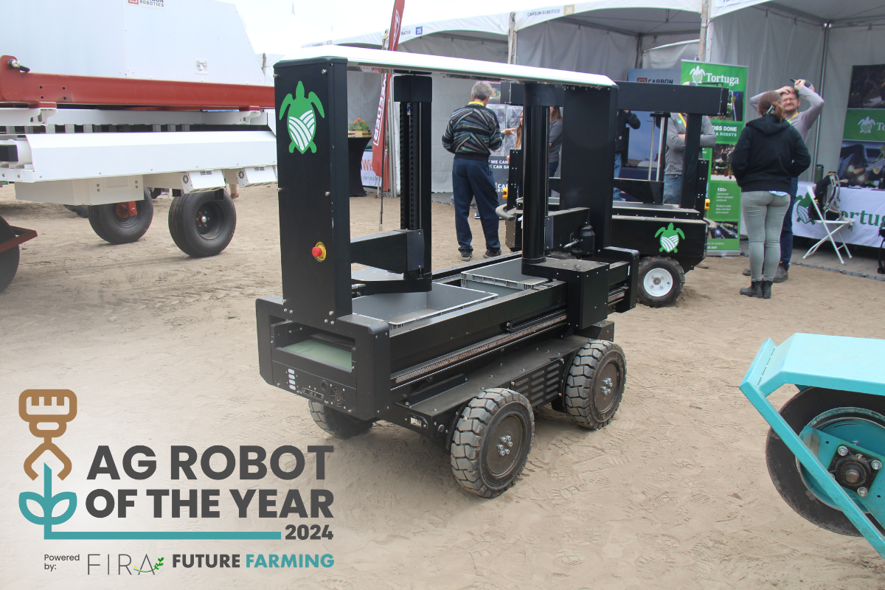
About the Ag Robot of the Year Award:
The Ag Robot of the Year award aims to assist farmers worldwide in selecting the right robot for their farming operations. The winners were revealed during the World Forum for Agricultural Robotics (FIRA) on 8 February 2024, in Toulouse/Auzeville-Tolosane, France. Manufacturers of field and harvesting robots for outdoor crops looking to qualify for the Ag Robot of the Year award in 2025 are encouraged to ensure their robots are included in the Future Farming field robot buyers' guide.
About Future Farming:
Future Farming serves as a vital global knowledge source for crop growers seeking the latest insights into precision agriculture and new crop improvement technologies. It offers comprehensive information and expertise on topics ranging from drones and agricultural machinery to big data, precision farming, and tools for crop improvement. Future Farming provides arable farmers with essential knowledge to enhance their farming practices through its magazine, website, newsletter, social media channels, webinars, seminars, and participation in major trade fairs.
About World FIRA:
The World Forum for Agricultural Robotics (FIRA) stands as the largest international AgTech-robotics exhibition, showcasing cutting-edge technologies for autonomous farming. It hosts speakers and researchers from around the world who present various research projects and innovations in the agricultural robotics field.
Contacts: Geert Hekkert, editor in chief Future Farming ( geert.hekkert@misset.com). Gwendoline Legrand, Co-director | Communication Manager GOFAR | FIRA ( gwendoline@fira-agtech.com)
Note: Attached Tortuga AgTech image included in the email.

